Release Notes

(Multiple Product in AP/Add on’s in AP/ET)

Multiple Product in AP

1. **Introduction:**

* By default 3 Products for corresponding Partner’s will be populated on Action Plan according to the sequence given on the Product default allocation record.
* First priority will be Partner Products and then Business Unit products.
* First 3 products for each asset class will be displayed on the Action Plan for each Goal.

1. **Functionalities :**

* Product Default allocation will have 3 record types :

1. Partner Products (Look-up to Partner)
2. Business Unit Products (Look-up to Business Unit)
3. Basket Products (Look-up to Business Unit with additional fields)

* In the records Name, Asset Class and Investment type will be auto-populated depending on the product selected from the product itself.
* There is 1 check box in the Goal Section on Action plan which will allow to display same Product Table in Action Plan HTML/PDF.

**Data Model**

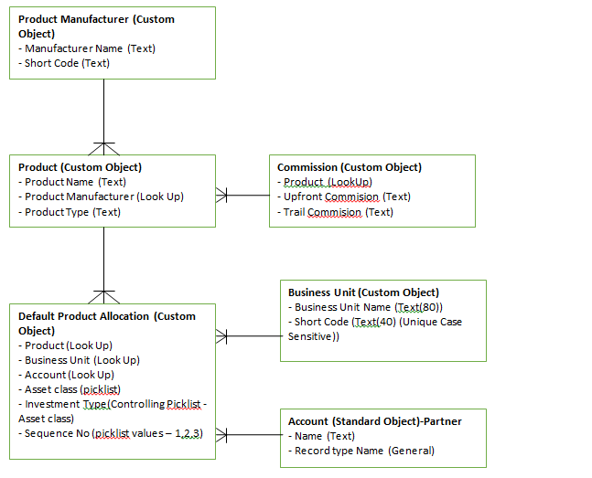

Add on’s in AP/ET

1. **Introduction:**

**Freedom has introduced new section in Action Plan**

* + Fixed Deposit
  + Loan
  + Bond

1. **Functionalities :**

## At Action Plan Level

* A New Section “**Other Products**” will be introduced in Action Plan.

### **Loan section**

* Records will be provided an option to Open Execution Tracker for them with a picklist as (Yes/No).
* Email notification needs to go out to ET owner when ET is opened. PO needs to get email and SMS.
* As soon as action Plan is created or updated, its related RPP is calculated based on the Amount entered.

### **Fixed Deposit section**

* Records will be provided an option to Open Execution Tracker for them with a picklist as (Yes/No).
* Email notification needs to go out to ET owner when ET is opened. PO needs to get email and SMS.
* Scheme Name will come with dropdown picklist from Product Master depending on the Selected company Name.
* As soon as action Plan is created or updated, its related RPP is calculated based on the Amount entered.

### Bonds section

* Records will be provided an option to Open Execution Tracker for them with a picklist as (Yes/No).
* Email notification needs to go out to ET owner when ET is opened. PO needs to get email and SMS.
* Category will come with dropdown picklist from Product Master depending on the Selected company Name.
* As soon as action Plan is created or updated, its related RPP is calculated based on the Amount entered.

## At Execution Tracker Level

* In Loan/FD/Bond section’s if **ET to be opened** field is marked as **yes**, then following process is executed.
* As soon as ET record is created or updated, its related RPP is created or updated.
* Once ET record is created, on Click of Open Link, MET Screen will be displayed.
* MET member needs to fill Agreed Amount and assign it to Operation Team Members.
* Email notification to Ops team member. PO also intimated via email and SMS.
* If Operation Team gets all the required information, they will manually close that record.
* There is no partial Execution concept for this section.

## At RPP Level

* Create ARPP records after creation of Action Plan records and calculate actual Upfront Commission base on Investment / Product type.
* After Insert trigger on Approve Action Plan object to Crate ARPP detail records.

**Following steps are using to Calculating actual commission:**

* Collect All Action Plan record where ET has opened and store APs separately based on Type (Bond/Fixed Deposit/Loan) and
* Collect suggest products from Product Master.
* Executed Each Category of Action plan newly created records and create corresponding ARPP records. While creating ARPP record with Upfront commission calculation we have checked Following Condition.
* If Product name is not available on Product Master Object then Put Remark “Product Detail is not found”.
* If Product name is found but active commission is not available then put remark “Commission Detail is not found”.
* In Case of Fixed Deposit section find the valid month’s interval active Commission detail.
* In case of Bond, Loan find only active Commission detail.
* ARPP detail is having reference fields of Approve Action Plan, Product Master, Execution tracker and Commission. When we are creating new ARPP record at same time we are initializing all reference fields except Execution Tracker.
* Commissions get calculated for each category of action plan.

**Using those calculations we have created ARPP records with Action Plan records. Following steps are mentioning how we are relating Execution tracker with ARPP detail record.**

* After Insert and update trigger on Execution Tracker.
* ARPP record will updated when Execution tracker is created or updated.
* Execution tracker records are directly related with Action Plan record therefore first we are collecting all Action plan references from ET and retrieving All ARPP detail records related to collected Action Plan references.
* Since ARPP have all required reference so using Commission reference we have calculated Upfront commission. Execution_Tracker_Upfront_Comm_Amount fields hold Upfront commission.

**Data Model**

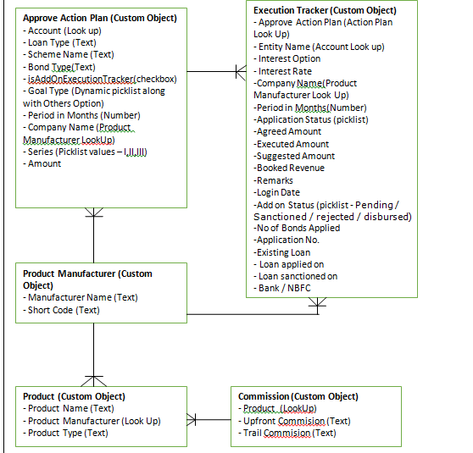

Component used in Multiple Product in AP/Add on’s in AP/ET

1. **Object**

|  |  |  |
| --- | --- | --- |
| **Name** | **Type** | **Comment** |
| Department | Custom object | New |
| Team Member | Custom object | New |
| Business Unit | Custom object | New |
| Product Master |  |  |
| Product Manufacturer | Custom object | New |
| Prdocut Default Allocation | Custom object | New |
| Commission | Custom object | New |
| Approve Action Plan | Custom object | New |
| Execution Tracker | Custom object | New |
|  | Custom object | New |
| 1. **Apex Class** |  |  |
| ActionPlanController | Apex Class | New |
| ActionPlanServices | Apex Class | New |
| ApprovedPlanBean | Apex Class | New |
| APUpdateforETHandler | Apex Class | New |
| ExecutionTrackerController | Apex Class | New |
| ExecutionTrackerHandler | Apex Class | New |
| RelatedExecutionTrackerController | Apex Class | New |
| ExecutionTrackerServices | Apex Class | New |
| ActionPlanUtility | Apex Class | New |
| EditETforLoanController | Apex Class | New |
| EditETforFixedDepositController | Apex Class | New |
| EditETforBondController | Apex Class | New |
| ViewETdetailsController | Apex Class | New |
| ExecutionTrackerForOpsTeamController | Apex Class | New |
| CommissionHandler | Apex Class | New |
| ARPPCalculationHandler | Apex Class | New |
| ProductDefaultAllocationHandler | Apex Class | New |
| 1. **Visualforce Page** |  |  |
| ExportToExcelARPPDetail.page | Visualforce Page | New |
| RelatedExecutionTracker | Visualforce Page | New |
| EditETforFixedDeposit | Visualforce Page | New |
| EditETforBond | Visualforce Page | New |
| ViewETdetails | Visualforce Page | New |
| NewEditAccount | Visualforce Page | New |
| ExecutionTrackerForOpsTeam | Visualforce Page | New |
| EditETforLoan | Visualforce Page | New |
| ActionPlan | Visualforce Page | New |
| ARPPDetail | Visualforce Page | New |
| ActionPlanhtml | Visualforce Page | New |
| ExecTracker | Visualforce Page | New |
|  |  |  |
| 1. Field |  |  |
| Type__c | Arpp Details | old |
| Type__c | Execution Tracker | old |
| Max Months | Commission | New |
| Min Months | Commission | New |
| Interest Rate Offered | Execution Tracker | New |
| Company Name | Execution Tracker | New |
| Period in Months | Execution Tracker | New |
| Bond Type | Execution Tracker | New |
| No of Bonds Applied | Execution Tracker | New |
| Add on Status | Execution Tracker | New |
| Loan Type | Approve Action Plan | New |
| Bond Type | Approve Action Plan | New |
| Goal Type | Approve Action Plan | New |
| Period in Months | Approve Action Plan | New |
| Company Name | Approve Action Plan | New |
| isAddOnExecutionTracker | Approve Action Plan | New |
| Existing Loan | Execution Tracker | New |
| Loan applied on | Execution Tracker | New |
| Loan sanctioned on | Execution Tracker | New |
| Loan Type | Execution Tracker | New |
| Goal_Name__c | Execution Tracker | New |
| Bank / NBFC Name | Execution Tracker | New |
|  |  |  |
|  |  |  |
|  |  |  |
|  |  |  |
|  |  |  |
|  |  |  |
| **5)Apex Trigger** |  |  |
| ActionPlan | Apex Trigger | Old |
| ExecutionTracker | Apex Trigger | Old |
| ProductDefaultAllocationTrigger | Apex Trigger | New |
| CommissionTrigger | Apex Trigger | Old |
|  | Apex Trigger | New |
| **6) Test Class** |  |  |
| Test_ExecutionTrackerController | Test Class | New |
| Test_ExecutionTrackerForOpsTeam | Test Class | New |
| EditETforSTPControllerTest | Test Class | New |
| TestArppCalculationHandler | Test Class | New |
| APUpdateforETHandlerTest | Test Class | New |
| EditETforLoanControllerTest | Test Class | New |
| EditETforFixedDepositControllerTest | Test Class | New |
| EditETforBondControllerTest | Test Class | New |
| ActionPlanControllerTest | Test Class | New |
| ProductDefaultAllocationHandlerTest | Test Class | New |
|  |  |  |